“Intelligent AI-Based Smart Dairy Farm Management System”

CO-1 ASSESSMENT TOOL-2
Agile Sprint Planning & User Story Workshops
Submitted in the partial fulfilment for the course of
CSA1017 - SOFTWARE ENGINEERING
for the award of the degree of
BACHELOR OF ENGINEERING
IN
COMPUTER SCIENCE AND ENGINEERING
Submitted by
R KALAI AMUDHAN(192511292)
Under the Supervision of
Dr. LATHA R


SIMATS ENGINEERING
Saveetha Institute of Medical and Technical
Sciences Chennai-602 105
July 2026

TABLE OF CONTENTS:-

S. No. | Contents | Page No.
1 | Project Vision and Stakeholders | 3
2 | Project Vision | 3
3 | Stakeholder Identification | 3
4 | Epics and User Stories | 4
5 | Acceptance Criteria | 5
6 | Product Backlog Prioritization | 7
7 | Sprint Backlog | 8
8 | Story Point Estimation | 9
9 | Sprint Goal and Expected Deliverables | 10
10 | Conclusion | 12

1. Project Vision and Stakeholders
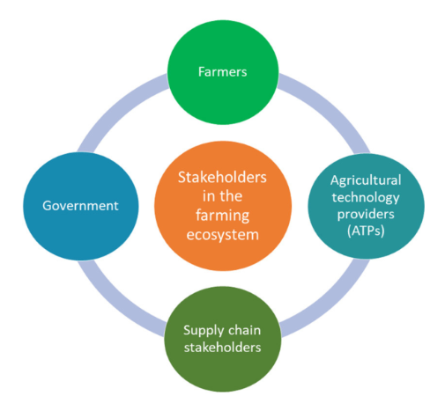
1.1 Project Vision
The vision of the Intelligent AI-Based Smart Dairy Farm Management System is to develop a smart, AI-powered platform that continuously monitors cattle health, predicts diseases, optimizes feeding schedules, tracks milk production, and provides real-time farm analytics.
The system will combine AI, IoT sensors, wearable devices, and cloud computing to help farmers make data-driven decisions, improve animal welfare, increase milk production, reduce operational costs, and improve overall dairy farm productivity.
Project Objectives
- Continuously monitor cattle health.
- Predict possible livestock diseases using AI.
- Optimize feeding schedules according to cattle requirements.
- Track and analyze milk production.
- Generate farm performance reports.
- Improve livestock welfare.
- Reduce operational expenses.
- Increase dairy farm productivity and profitability.
1.2 Key Stakeholders
Stakeholder | Role and Interest
Dairy Farm Owner | Monitors overall farm performance, productivity, and profitability.
Farmers / Farm Managers | Manage cattle, feeding, health, and daily operations.
Veterinarians | Analyze health alerts and provide medical recommendations.
Farm Workers | Perform daily activities such as feeding and cattle care.
Cattle / Livestock | Primary subjects whose health and welfare are monitored.
AI System | Predicts diseases and analyzes farm data.
IoT Sensors and Wearable Devices | Collect health and environmental data.
2. Epics and User Stories
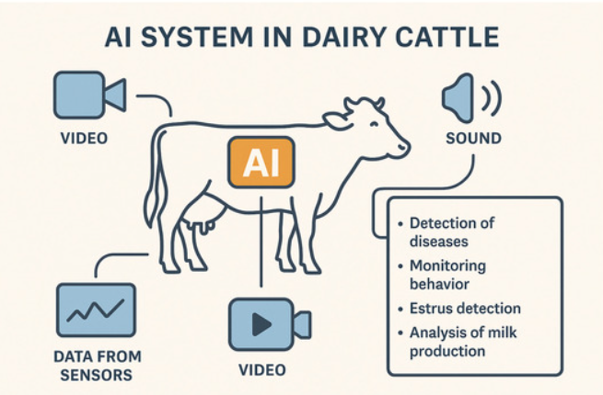
The requirements are divided into major Epics.
Epic 1: Cattle Health Monitoring
User Story US-01
As a farmer, I want to monitor the health condition of each cattle using sensor data, so that I can identify health problems early.
User Story US-02
As a veterinarian, I want to view the health history of cattle, so that I can analyze their health condition and provide suitable treatment.

Epic 2: AI-Based Disease Prediction
User Story US-03
As a farmer, I want the system to predict possible diseases using AI, so that I can take preventive action before the disease becomes serious.
User Story US-04
As a veterinarian, I want to receive alerts about cattle with abnormal health conditions, so that I can examine them quickly.

Epic 3: Smart Feeding Management
User Story US-05
As a farm manager, I want to create optimized feeding schedules, so that cattle receive the required nutrition at the right time.
User Story US-06
As a farmer, I want to receive feeding reminders, so that scheduled feeding activities are not missed.

Epic 4: Milk Production Tracking
User Story US-07
As a farmer, I want to record daily milk production for each cattle, so that I can track production performance.
User Story US-08
As a farm owner, I want to view milk production trends, so that I can identify changes in dairy productivity.

Epic 5: Farm Analytics and Reports
User Story US-09
As a farm owner, I want to view farm performance analytics, so that I can make data-driven management decisions.
User Story US-10
As a farm manager, I want to generate farm performance reports, so that I can analyze productivity and operational efficiency.

3. Acceptance Criteria
The Given–When–Then format is used to define measurable acceptance criteria.
US-01: Monitor Cattle Health
Given a cattle wearable sensor is connected to the system,
When health data such as temperature and activity is collected,
Then the system shall display the current health status of the cattle.
Given abnormal health data is detected,
When the system analyzes the sensor readings,
Then the system shall mark the cattle as requiring attention.

US-03: AI-Based Disease Prediction
Given sufficient cattle health data is available,
When the AI model analyzes the data,
Then the system shall predict possible health risks or diseases.
Given a high-risk disease prediction is generated,
When the prediction is confirmed by the system,
Then an alert shall be sent to the farmer or veterinarian.

US-05: Optimized Feeding Schedule
Given cattle information and nutritional requirements are available,
When the farm manager creates a feeding plan,
Then the system shall generate an appropriate feeding schedule.
Given a feeding activity is scheduled,
When the feeding time is reached,
Then the system shall provide a reminder to the responsible user.

US-07: Track Milk Production
Given daily milk production data is available,
When the farmer enters the production quantity,
Then the system shall store the data against the corresponding cattle.
Given production data has been recorded for multiple days,
When the farmer views the production history,
Then the system shall display production trends.

US-09: Farm Analytics
Given health, feeding, and milk production data is available,
When the farm owner opens the analytics dashboard,
Then the system shall display relevant farm performance information.
4. Product Backlog Prioritization
The backlog is prioritized based on business value, user importance, risk, and dependencies.
Priority | User Story | Business Value | Reason
P1 | US-01: Monitor cattle health | Very High | Core feature of the system
P1 | US-03: Predict diseases using AI | Very High | Helps prevent disease outbreaks
P1 | US-07: Track milk production | Very High | Directly measures farm productivity
P1 | US-05: Optimize feeding schedules | High | Improves cattle health and productivity
P2 | US-04: Health alerts | High | Enables quick action
P2 | US-09: Farm analytics | High | Supports data-driven decisions
P2 | US-06: Feeding reminders | Medium | Improves operational efficiency
P3 | US-08: Milk production trends | Medium | Useful for performance analysis
P3 | US-10: Performance reports | Medium | Supports long-term analysis

Prioritization Logic
The following features receive the highest priority:
- Cattle health monitoring
- AI disease prediction
- Milk production tracking
- Feeding optimization
These features directly support the primary goals of animal welfare, disease prevention, productivity, and profitability.

5. Sprint Backlog
Sprint Duration: 2 Weeks
Sprint Goal
To develop the core foundation of the Smart Dairy Farm Management System by enabling cattle registration, health monitoring, sensor data collection, and basic health alerts.

Sprint Backlog

User Story | Tasks
 | Design cattle registration module
 | Create cattle database
US-01: Monitor Cattle Health | Connect health sensor data
 | Display temperature and activity data
 | Develop health monitoring dashboard
 | Define abnormal health conditions
 | Create alert logic
US-04: Health Alerts | Display health alerts
 | Test notification system
 | Design milk entry form
 | Create milk production database
US-07: Track Milk Production | Store daily milk records
 | Display production history

6. Story Point Estimation
The Fibonacci sequence is used for estimation:
1, 2, 3, 5, 8, 13
Higher story points indicate greater complexity, effort, and uncertainty.
User Story | Story Points | Justification
US-01: Monitor Cattle Health | 8 | Requires sensor integration, data processing, and dashboard development.
US-03: AI Disease Prediction | 13 | Requires data collection, AI model development, training, testing, and prediction.
US-05: Optimize Feeding Schedule | 8 | Requires cattle data analysis and schedule generation.
US-07: Track Milk Production | 5 | Requires data entry, database storage, and basic tracking.
US-04: Health Alerts | 5 | Requires abnormal condition detection and notification functionality.
US-06: Feeding Reminders | 3 | Requires schedule-based reminders.
US-09: Farm Analytics | 8 | Requires combining multiple data sources and creating analytics dashboards.
US-10: Performance Reports | 5 | Requires report generation from existing farm data.
Estimation Justification
The most complex story is AI-Based Disease Prediction, which is assigned 13 story points because it requires:
- Historical health data
- Data preprocessing
- AI model development
- Model training
- Prediction testing
- Integration with the main system
7. Sprint Goal and Expected Deliverables
Sprint Goal
To create a functional foundation for intelligent dairy farm management by implementing cattle registration, health monitoring, milk production tracking, and basic alert functionality.
Expected Deliverables
At the end of the sprint, the following features should be completed:

1. Cattle Registration
- Add cattle details.
- Assign a unique cattle ID.
- Store cattle information securely.
2. Health Monitoring
- Display health data.
- Monitor sensor readings.
- Show the current health status.
3. Health Alerts
- Detect abnormal conditions.
- Display warnings to farmers.
- Notify veterinarians when required.
4. Milk Production Tracking
- Record daily milk production.
- Store production data.
- View production history.
5. Basic Dashboard
The dashboard should provide:
- Number of cattle
- Healthy cattle count
- Cattle requiring attention
- Daily milk production
- Health alerts

Conclusion
The Intelligent AI-Based Smart Dairy Farm Management System demonstrates how Agile software engineering practices can be used to plan and develop a modern smart farming solution. The project requirements were systematically organized into Epics and User Stories, with clear Given–When–Then acceptance criteria to ensure that each requirement is measurable and testable.
The Product Backlog was prioritized based on business value, user needs, project dependencies, and system importance. High-priority features such as cattle health monitoring, AI-based disease prediction, feeding management, and milk production tracking were selected for development in planned sprints. The use of Fibonacci story points helped estimate the effort and complexity of each user story.
The planned Sprint focuses on delivering the core functionalities of the system, including cattle registration, health monitoring, health alerts, and milk production tracking. These features provide a strong foundation for future development.
In future sprints, advanced features such as AI disease prediction, intelligent feeding optimization, real-time analytics, automated reports, and predictive farm management can be implemented. By continuously delivering and improving features through Agile development, the system can help farmers make better data-driven decisions.
Overall, this Agile Sprint Planning and User Story Workshop provides a structured roadmap for developing a smart dairy farm management system that can improve livestock health, animal welfare, milk production, operational efficiency, and farmer profitability.
